ENTERPRISE CYBERSECURITY HOME LAB (Phase 1)

Introduction:
The primary objective of this phase was to design and implement a fully isolated, segmented, and firewalled corporate Local Area Network (LAN) using virtualization. This foundation ensures that all subsequent phases (Active Directory, Logging, Defence, and Attack Simulation) operate in a realistic, controlled, and protected environment, independent of the host machine's physical network.

Objectives:
- Network Isolation: Created a custom VMWare virtual network with explicit isolation.
- Gateway Deployment: Successfully installed and configured the pfSense firewall/router.
- IP Schema Implementation: Configured the (10.0.10.0/24) subnet and established the gateway (10.0.10.1).
- DHCP/DNS Policy: Configured pfSense DHCP to point clients to the future Domain Controller’s IP (10.0.10.10).

Software/Tools Used in whole project:
- Hypervisor: VMware Workstation Pro 17
- Operating Systems:
  - Windows 10 Enterprise
  - pfSense
- Analysis Tools: ipconfig, ping

Methodology:
This section documents the foundational design that ensures the lab is isolated, scalable, and replicates an enterprise environment's segmentation.
Logical Network Topology:
- In this lab the pfSense firewall acts as the central router and security gateway.
- The entire internal network is segmented onto a private VMWare virtual switch, ensuring zero accidental communication with the host's physical network.
Virtualization Layer Configuration:
To enforce isolation and control the internal IP addressing, a custom VMWare virtual network was configured.
- VMware Network: Custom network VMnet was created (Edit > Virtual Network Editor)
- Isolation: The Host-only option was selected, and the VMWare's internal DHCP service and Host virtual adapter connection was explicitly disabled. This forces all internal VMs to rely solely on the pfSense appliance for all network services, including DHCP and DNS resolution.
- 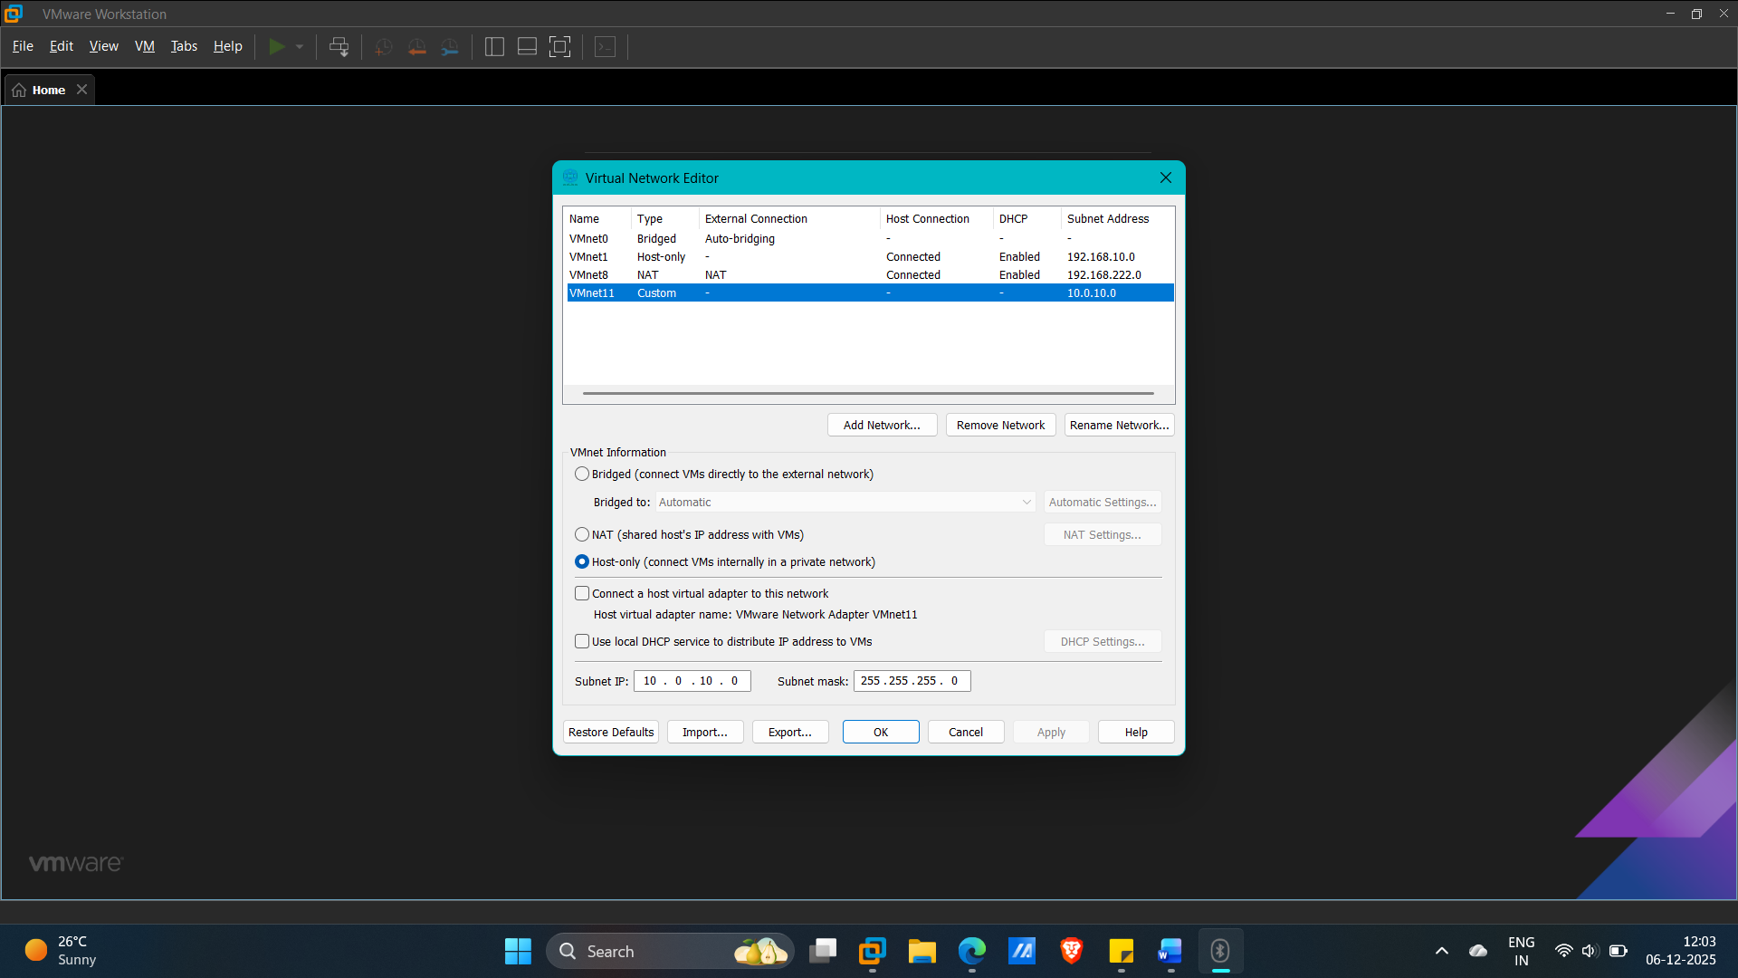
IP address and Naming Schema:
The following schema was adopted for the internal network (corp.local) operating on the 10.0.10.0/24 subnet.
Component | Hostname | IP Address | Subnet Mask | Description
Network ID | N/A | 10.0.10.0 | 255.255.255.0 (/24) | The network identifier.
Gateway/Firewall | pfSense-GW | 10.0.10.1 | 255.255.255.0 | First usable address; the router/firewall interface.
Domain Controller | DC01 | 10.0.10.10 | 255.255.255.0 | Static IP for the most critical infrastructure server.
SIEM Server | SIEM01 | 10.0.10.20 | 255.255.255.0 | Static IP for the centralized log platform.
Attacker VM | KALI01 | 10.0.10.66 | 255.255.255.0 | Static or reserved dynamic IP (easy to remember).
Client Range (DHCP) | WIN10-CL1, Ubuntu | 10.0.10.100+ | 255.255.255.0 | Dynamic addresses for user/desktop machines.
Broadcast Address | N/A | 10.0.10.255 | 255.255.255.0 | The last address in the subnet.

Network Core Deployment (pfSense):
This phase established the network perimeter and internal services. Here is the procedure:
- pfSense Installation: Installed on VMware with two network adapters. The first adapter (WAN) was mapped to VMWare NAT for external connectivity (internet), and second adapter (LAN) was mapped to the isolated WMnet11 for the internal network.
- Interface Mapping (LAN and WAN) setup to pfSense: To manage and separate traffic between external WAN and internal LAN, first need to configure interface mapping by using pfSense Assign Interface Setting.
- Interface Configuration: The LAN interface was statically configured with the gateway address 10.0.10.1.
- DHCP Service: The DHCP server was enabled on the LAN interface to serve the address range $10.0.10.100 - 10.0.10.254$. The DNS server option in the DHCP settings was set to the Domain Controller's future IP: 10.0.10.10.
pfSense Web Interface Configuration:
In this phase different essential services are configured after assigning interfaces in pfSense console. This configuration should be done in pfSense Web GUI.
To access pfSense Web GUI, go to any Client VM which is connected to Internal LAN via pfSense and type http://10.0.10.1/ (Because this IP address is the default gateway for pfSense).
Now starting the different configuration service for network in pfSense:
- Log in to the GUI: Use the default credentials: Username: admin, Password: pfsense.
- Security Hardening (Change Default Admin Password): CRITICAL SECURITY STEP: Immediately change the default admin password in System > User Manager.
- Configure Hostname/Domain: In System > General Setup, Hostname: pfSense-gw, Domain: corp.local
- Firewall DNS Configuration: In System > General Setup, set DNS Server 1: 10.0.10.10. This will force pfSense itself to query the Domain Controller for all internal name resolution, preserving the DC's authority.
- Configure DHCP Server: Enable DHCP in Services > DHCP Server > LAN tab by Check the box to Enable DHCP server on the LAN interface, Then Set DHCP Range start to 10.0.10.100 and the Range End to 10.0.10.254.
Essential Firewall rules setup:
These are the basic firewall rules configured through pfSense Web GUI to secure the internal network:
- WAN Interface Rules:
  - By default, pfSense is designed to block traffic coming from "private networks" (like 192.168.x.x or 10.x.x.x) on its WAN interface. This is a good security practice in a real-world setup, but in VMWare lab this should be allowed because VMWare’s NAT service assigns a private IP address to pfSense WAN port, So configure in pfSense to temporarily ignore this rule on WAN interface only.
  - Go to Interfaces > WAN, scroll down to the private network settings, then uncheck the box next to “Block private networks and lookback addresses”, Then Save and Apply changes.
- Verifying the LAN Rules:
  - The LAN interface needs a rule that allows your internal machines to talk to each other and get to the WAN (Internet). Which is the default rule in pfSense. Without this rule, nothing inside 10.0.10.0/24 can talk to the outside world.

Findings and Analysis:
This section documents the verification steps and analyses the successful integration of the core network components—VMware's custom virtual switch, the pfSense gateway, and the corporate IP schema.
Successful IP Schema Implementation:
The defined IP addressing schema 10.0.10.0/24 was successfully implemented, with the pfSense appliance acting as the primary 10.0.10.1 gateway and DHCP server.
- pfSense DHCP Verification:
  - The pfSense DHCP service was confirmed to be operational and issuing addresses within the defined dynamic range 10.0.10.100 - 10.0.10.254.
  - Verification was performed on the WIN10-CL1 client VM using below command (executed in PowerShell).
  - Command: ipconfig /all
  - Expected Result:
    - IPv4 Address: 10.0.10.100 – 10.0.10.254
    - Default Gateway: 10.0.10.1
    - DNS Server: 10.0.10.10
  - Actual Result:
    - IPv4 Address: 10.0.10.100
    - Default Gateway: 10.0.10.1
    - DNS Server: 10.0.10.10
  - Below is the screenshot:
  - 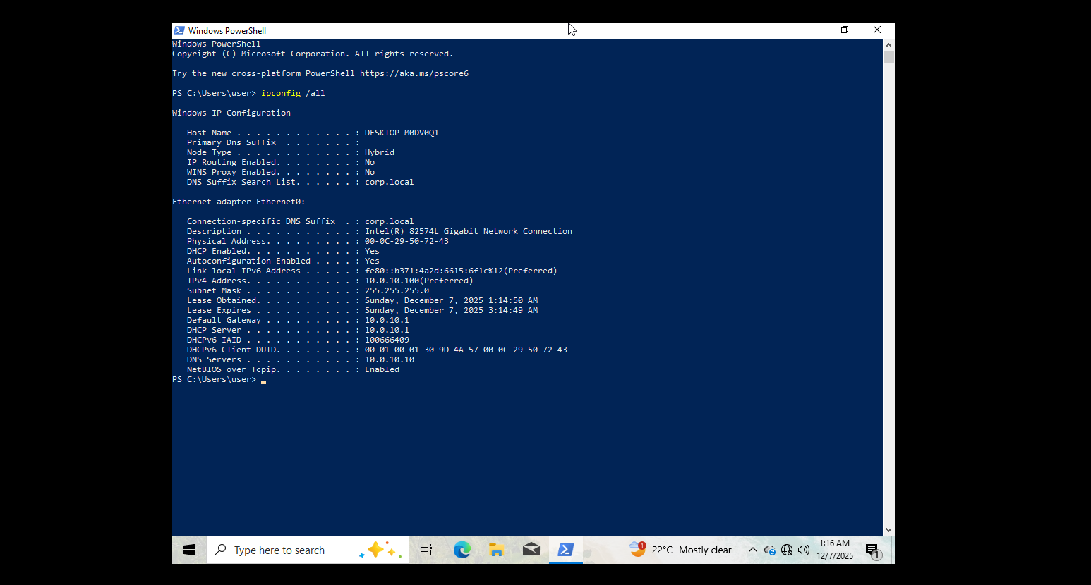
- Core Connectivity and Firewall Validation:
  - All network connectivity tests were successful, validating both the base network configuration and the necessary adjustments made to the pfSense firewall.
  - Here we have to check Gateway reachability, External Internet Access, and External DNS resolution:
    - Gateway Reachability:
      - Command: ping 10.0.10.1
      - Expected result: 4 successful replies
      - Actual result: Pass
    - External Internet Access:
      - Command: ping 8.8.8.8
      - Expected result: 4 successful replies
      - Actual result: Pass
    - External DNS Resolution:
      - Command: ping google.com
      - Expected result: 4 successful replies with IP address.
      - Actual result: Pass
  - Below is the screenshot:
  - 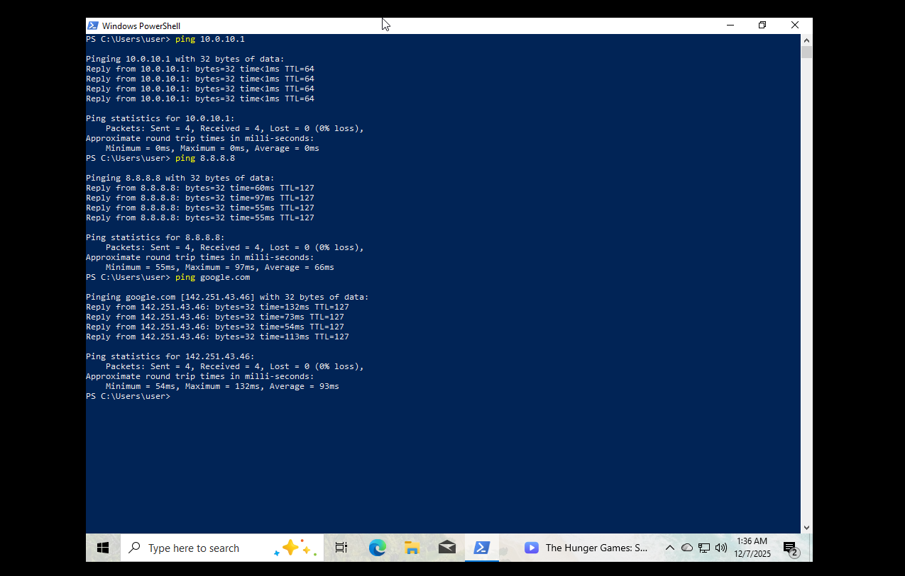
- Analysis of Firewall Implementation:
  - The required firewall adjustments were implemented to maintain isolation while ensuring functionality:
    - WAN Interface: The default "Block private networks and loopback addresses" rule was disabled. This was a necessary analysis step to resolve the expected conflict arising from VMWare's use of a private IP range on the pfSense WAN interface.
    - LAN Interface Rules: The two critical rules designed to enforce Active Directory reliance were implemented and validated by the successful ping google.com test:
      - Pass DNS Traffic: An Allow rule was placed to permit all clients (LAN net) to use 10.0.10.10 for Port 53 (DNS).
      - Block Foreign DNS Traffic: A subsequent Block rule was implemented to deny all other Port 53 traffic to Any destination, ensuring clients are restricted to using the future DC's DNS service.

Conclusion:
All objectives for Phase 1: Network Architecture have been successfully achieved and verified. The corporate LAN is fully isolated, the gateway is functional, and the necessary security policies (DNS reliance) have been established. The lab is ready to proceed to Phase 2.
The next step is Phase 2: Core Services, which focuses on deploying Windows Server 2022 and configuring Active Directory on (10.0.10.10).

